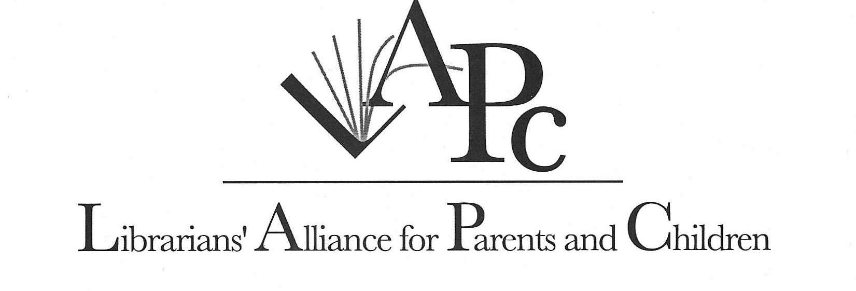Minutes
January 19, 2005
North Shore Public Library

Libraries represented: Brookhaven, Central Islip, Commack, Hauppauge, Huntington, Lindenhurst, Longwood, Mastics-Moriches-Shirley, Middle Country, North Shore, Northport-East Northport, Patchogue-Medford, Quogue, Smithtown, South Huntington, SCLS

The first half of the meeting was devoted to updating the official LAPC history. Lori will draft the updated version and send it out for final approval. Discussion of the LAPC list serve followed. The group approved the text description prepared by Marie. The list serve will be activated once the e-mail addresses are checked for accuracy. Members should expect to see a “Welcome to LAPClist” message soon. The address is LAPClist@lists.suffolk.lib.ny.us. Information about the list serve will be included in the updated history.

Louise brought to our attention that the “I am Your Child Foundation” is now the “Parents’ Action for Children”. Their valuable resources can be found at http://www.iamyourchild.org/. She also reported that you no longer need a user password to access the CDR (Community Resource Database of Long Island). MCPL welcomes telephone inquires concerning the CRD. She also reported that the Family Service League makes counseling services available in library settings. Call for more info.

Master copies of Toni’s new brochure, “It’s never too early to read to your baby” were distributed. Members not present will be sent a master. Toni is working with a committee to update the Family Resource Book: An Annotated Bibliography (originally published by the NYS Citizens Task Force on Child Abuse & Neglect in 1986). She will forward the LAPC bibliographies that were prepared/updated after 2000 and she is asking for any other suggestions of new titles and/or resources. The updated version will be available in both text and electronic format. Toni announced that Sarah Ali, the author of Baby Friendly Long Island, is very interested in offering library programs. Her phone number is (631) 271-2691 or she can be reached by e-mail at sarahazan@yahoo.com.

The following employment opportunities were announced:
Lindenhurst is looking for a full-time Children’s or Children’s/Young Adult Librarian. Contact Director Christine Salita.

Mastic-Moriches-Shirley is seeking a part-time Children’s Librarian.

Marilyn (Quogue) shared her success with some fingerplays as well as with Brain Games (Brain Games for Babies, Toddlers & Twos by Jackie Silberg.)

Mildred previewed the video Kindergarten Here I Come, and thought that it was over-priced for what it had to offer.

Other items that were flash-talked are included in the packet of handouts.

Jill informed us about a new resource person. Her name is Dr. Juliet Williams and she will address developmental issues. Longwood’s staff was very impressed. You can reach Dr. Williams at 331-2420.

The next meeting is the annual joint meeting with Nassau librarians scheduled for Wed., May 25th . The location will be announced.

L.Blend
1/20/05

